**BME Capstone Design Project Weekly Progress Report**

**Project Title:** KK01: Design of extremely small satellite

**Student Name:** Bethany Santos, Ho Yin Samuel Yeung, Owais Nakhuda

**Reporting Week:** Mar 4 - Mar 8

**Project Manager of the Week:** Bethany Santos

**Tasks Outlined in Previous Progress Report:**

* Strategy to determine transceiver gain and power
* Algorithm for secure packet transmission

**Progress made in Reporting Week:**

* A parts list of components created to make new boards for testing and prototyping
* Plan structure for the understanding and implementation of the radio modem confirmed

The main goals for this week was to get the parts lists needed to buy to build another board for prototyping and testing the C&DH board. As well as to reverse engineer the radio modem to use as a black box between the C&DH board. All testing and results will be documented for future reference.

The current parts list is listed below:

|  |  |  |  |
| --- | --- | --- | --- |
| **Manufacturer Part #** | **Manufacturer** | **Description** | **Unit Price** |
| MCP1826-ADJE/AT | Microchip Technology | IC REG LINEAR POS ADJ 1A TO220-5 | $ 1.53 |
| LTC1153CS8#TRPBF | Linear Tech/Analog Devices | IC ELECTR CIRCUIT BREAKER 8-SOIC | $ 9.11 |
| PA-SOD6SM18-32 | Logical Systems Inc | ADAPTER 32SOIC TO 32DIP | $ 22.70 |
| ABX00012 | Arduino | ARDUINO MKR ZERO W/ HDR ATSAMD21 | $ 34.95 |
| PIC16F628A-E/P | Microchip Technology | IC MCU 8BIT 3.5KB FLASH 18DIP | $ 2.90 |

In the TubeSat design, we use a method of encoding data where data is converted (at slow rates) into an audio wave that can is both audible by humans and transmitted over modems. The radio communication hardware installed on the TubeSat consists of two main modules: (1) Terminal Node controller (TNC) and (2) Radio Module as seen in the schematic below:

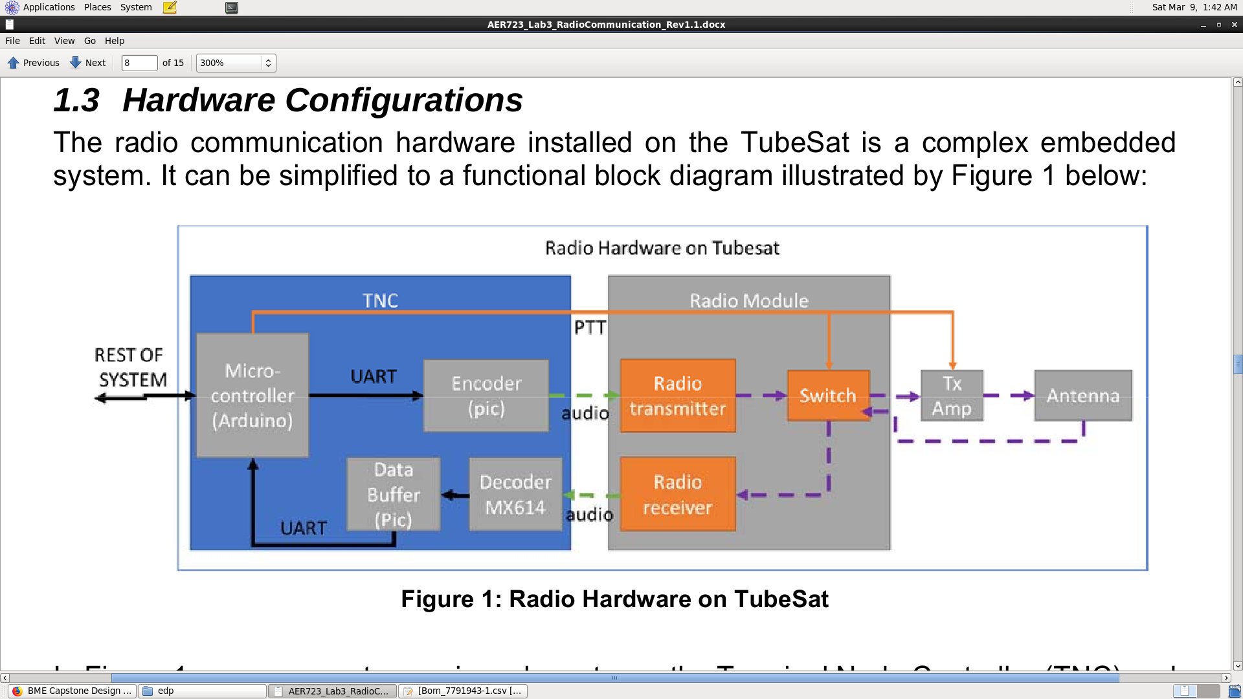

To get a better understanding on how the radio modem works and how this can be implemented on to the TubeSat, we plan to build an FM radio modem emulator that emulates the decoding and encoding techniques of the real system. This emulator will focus on the TNC component of the Radio Hardware. The goal here is to convert strings of data to audio signals transmitted and received over an FM channel.

**Tasks for Next Week:**

* Assemble the radio modem module
* Program FM Radio Modem emulator with Arduino IDE
* Use Matlab for visualization of the signals and testing
* Once above list has been achieved, start implementation with the rest of the TubeSat